IoT-Based Water Quality Monitoring System
Pratik S. Dube, Prof. S. A. Chaudhari
Department of Electronic Science, M.Sc. (Electronic Science), Sangamner Nagarpalika Arts, D. J. Malpani Commerce and B. N. Sarda Science College, Sangamner, Ahilyanagar-422605(M. S.), India.
pratikdube01@gmail.com, shashangarchaudhari@gmail.com

Abstract
Water Quality is a crucial factor of our life and for all the living beings on the Earth, Impacting human health, agriculture, and industrial processes. Among the key parameters of water quality, turbidity, conductivity and temperature. Which indicate the particles, suspended solids, dissolved ions, and the temperature of the water, respectively. In this paper, we have developed a system that can measure the parameters of water in real time. In this system we used turbidity sensor for turbidity detection, tds sensor with conducting probes for measuring the amount of dissolved salt and other minerals in water, providing an indication of water quality and purity and a ds18b20 waterproof temperature sensor for monitoring the temperature of the water. This system provides cost effective and accurate monitoring of the water quality, with potential application in environmental monitoring, water treatment plant, and industrial processes.
Keyword: Turbidity sensor, TDS sensor, DS18B20 temperature sensor, Water quality, Think speak, ESP32, IoT.

1.INTRODUCTION:
Monitoring the quality of water has become essential for ensuring the safety, sustainability, and usability of water resources for human consumption, agriculture, industry, and ecosystems. It involves measuring chemical, biological parameters for detection of contamination, to prevent health risks, and support environment conservation. Some primary indication of water quality are turbidity, conductivity and water temperature.
- Turbidity means the cloudiness or haziness in the water caused by the presence of the small, suspended particles. These particles may include silt, clay, microorganisms, and some small particles. High turbidity level can cause major concern for health, environmental sustainability, and industrial applications.
- Conductivity measures water’s ability to conduct electric current, which is directly proportional to concentration of dissolved ions in water, such as salts, minerals, and other chemicals. High conductivity indicate increase in pollution, while low conductivity indicates absence of ions.
- Temperature of water play a crucial role in maintaining the balance of aquatic ecosystems, and water quality. warmer the water less dissolved oxygen, making difficult for surviving of the aquatic life. Due to high temperature, it may lead to increase in harmful reactions due to presence of chemical in the water.
Conventional methods for measuring turbidity often involve visual inspection or manual testing, while conductivity is typically measured using electrical probes. Water temperature is usually measured using thermometers or temperature probes, but manual measurements can be inconsistent and lack real-time monitoring capabilities. These methods can be slow, costly, and labour-intensive. This paper presents the development of an integrated system that uses optical methods for turbidity measurement, combines it with an electronic sensor for conductivity measurement, and incorporates a temperature sensor to monitor water temperature variations. This provides a reliable and efficient way to monitor water quality in real time. The internet of things (IOT) is a technology which is used to collect the data from various devices and send data over internet without any human interaction.
In IoT-based water quality monitoring, this system provides real-time data collection of different water samples and transmits this data to the cloud, allowing users to access and monitor water quality remotely. The collected data can be publicly displayed for transparency and awareness or kept private, shared only with authorized individuals as per the user's preference.
  - Problem statement: -
Water pollution is increasing day by day affecting human health, agriculture and our ecosystem. Traditional water quality monitoring methods include manual sampling and testing in the laboratories, which are time consuming, expensive, data gaps, and lack of real-time monitoring, due to this limitation it become difficult to timely detect the water quality and prevent water from getting contaminated. With the advancement in the IoT (internet of thing), we need an automatically water quality monitoring system, that continuously monitor the different parameters of the water like temperature, turbidity, and TDS (total dissolved solids).

  - Scope of Project: -
This project aims to develop a IoT-Based water quality monitoring system using ESP32, interfacing multiple sensors with ESP32, sending the collected data to cloud platform thingspeak. This system continuously monitors the water quality and send data to thingspeak cloud and display on LCD screen locally, making it easy to monitor the water quality on-site and remotely. Ensuring the good water quality for public health improvement. Additionally supporting the smart cities and sustainable development for better water resource management.
1.3 Aim of the project: -
This project aims to develop an IoT-Based water quality monitoring system to ensure W.H.O water standards are met for safe drinking water.

  - Objective of the project: -
The objective of this project is to:
a) Develop a system based on IoT that will continuously monitor the water quality
b) Make the evaluation in the system with more advanced sensors and techniques.
2.LITERATTURE REVIEW
A.N. Prasad, K. A. Mamun, F. R. Islam, H. Haqva entitled “Smart Water Quality Monitoring System” published in 2015. This paper presents the frequent require of the data collecting network for the water quality monitoring for Fiji using IoT and remote sensing technology. In this paper they describe how the water is getting polluted around Fiji and monitoring different parameters of this water using IoT technology.
Mrs. R.J. Sapkal, Ms. Pooja Wattamwar, Ms. Rani Waghmode, Ms. Umrunsisa Tamboli entitled “IOT Based Water Monitoring System” published in 2019.This paper describes the need of effective and efficient water level monitoring and control the water quality in flat system to keep the human resources healthy and sustainable, and to reduce the usage of water for household purposes. They used ARM controller and some sensor to measure different water parameters and send the information to relevant stakeholder via web portal or mobile application.
Adetunji A.C, Prof. Mrs F.M Dahunsi entitled “Development of IoT Water Quality Monitoring System Using PH, TDS and Temperature Sensor” published in 2025. In this paper it is described that how a water quality monitoring system is developed for monitoring different water parameters using ESP8266 and send data to think speak cloud.
Nikhil Kedia's research paper, “Water Quality Monitoring for Rural Areas – A Sensor Cloud-Based Economical Project” (2015), discusses various water quality monitoring methods, including the use of sensors, embedded systems, and cloud technology for data collection and dissemination. The study highlights the role of government, network operators, and local communities in ensuring effective information sharing. While direct automation of water quality improvement is not yet feasible, the paper emphasizes how sensor cloud technology and cost-effective solutions can enhance monitoring efficiency and raise public awareness about water quality in rural areas.
3.METHODOLOGY
  - Hardware Components: - This IoT Based Water Quality Monitoring System consists of different sensors, microcontroller, and cloud platform to ensure real time data display and remote access.
3.1.1. Sensors:
- Turbidity sensor: A Water Turbidity Sensor with Analog Output Module is used to determine the clarity of water quality by detecting the suspended particles present in the water.
- TDS sensor: An Analog TDS Sensor is used to measure TDS level of water and detect the dissolved ions and minerals in water.
- DS18B20 Temperature sensor: A waterproof temperature sensor that is used to measure the temperature of water accurately.
3.1.2. Microcontroller:
- ESP32: It is a powerful Wi-fi-enable microcontroller with built-in Wi-Fi and Bluetooth used to collect the data of the sensors and transmit it to thingspeak cloud, for this we provide network to esp32 through our mobile hotspot.
3.1.3. Cloud Platform:
- Thingspeak: A widely used cloud platform, for displaying the data of various IoT devise in real time and store this data.
3.1.4. Display module:
- I2C LCD Display: It is used to locally display real time readings of the sensors, without need for cloud connection.
3.2. Acquisition and Processing Data: - This process involves data collection, display locally, transmission and cloud integration.
- Data collection: The output of the sensors is connected with esp32 to collect and process the data.
- Data display: We have used an i2c lcd display for real-time displaying sensor readings, providing on site monitoring.
- Data Transmission: The collected sensor data is transmitted to a thing speak cloud through esp32 microcontroller via Wi-Fi.
- Cloud integration: The sensor data is stored and displayed in graphical form for easy remote monitoring.
3.3. Analyzing Data: The data collected from the turbidity sensor, tds sensor and ds18b20 temperature sensor is analysed to determine water quality based on predefined threshold values.
3.3.1 Analysis of Temperature (DS18B20):
- When temperature > 35°C → "It's HOT" (water is hot may cause health issues or scalding).
- When temperature ≤ 35°C → "It's NORMAL" (water is safe for drinking and use).
3.3.2. Analysis of TDS:
- 0 ppm - 50 ppm → "Good for Drink" (water quality is excellent).
- 50 ppm - 300 ppm → "Safe for Drink" (water quality is acceptable for drinking).
- 300 ppm - 600 ppm → "Unsafe for Drink" (water quality may require purification).
- Above 600 ppm → "Unacceptable!" (water quality is very bad).

3.3.3. Analysis of Turbidity:
- Below 20% → "It's CLEAR" (water is clean, less suspended particles).
- 20 - 50% → "It's CLOUDY" (water has moderate turbidity, contamination possible).
- Above 50% → "It's DIRTY" (water has high contamination, water is unsuitable for drinking).
This methodology is helpful for automated, efficient, and cost-effective approach to monitoring water quality, making real-time data accessible both locally on the I2C LCD display and remotely via thing speak cloud platforms.
4. SYSTEM DESIGN AND IMPLEMENTATION
4.1. Block Diagram: -
Mobile network

ESP32

Turbidity sensor
Thing Speak

TDS sensor

16x2 LCD Display
With i2c module
DS18B20 Temperature sensor

Power supply

Fig 4.1: Block diagram of our project

The above block diagram represents an IoT based water quality monitoring system that continuously measures water parameters using different sensors, processes the data with an ESP32 microcontroller, displays real-time readings on an I2C LCD display, and uploads data to ThingSpeak for cloud monitoring.
In this proposed block diagram consist of sensors (turbidity, tds, temperature) connected with the core microcontroller. The core controller is accessing the sensor value and processing them to transfer the data through internet. ESP32 is used as a core controller. The sensor data can be viewed on thingspeak cloud platform. The ESP32 collects data from all connected sensors and converts the analog readings into meaningful values. Using Wi-Fi ESP32 connects with internet and send the data to thingspeak with HTTP request. We created a thingspeak field where we can continuously monitor real time data of water quality. Users can be able to access the thingspeak dashboard via a mobile browser to check water quality from anywhere.
4.2. System Integration: -
The entire system can be powered using a 5V DC supply using adaptor or batteries, here we have used the 5V DC adaptor to power the ESP32 and other sensors in this system. Ensure the power supply is sufficient to support all connected sensors. Our system consumes approximately 1.13W when powered by the 5V DC.
Table 4.1: - Three water quality sensors with their technical specification
Sensors | Measurement range | Accuracy
Turbidity sensor | 0 – 4000 NTU | +5% to -5 %
TDS sensor | 0 – 1000 ppm | +10% to -10%
Temperature sensor | -55° to +125° C | +0.5° C to -0.5 °C

4.3. Flow Diagram: -
The flow diagram of the system is shown in Figure 4.2. it shows the flow of operation of the system. All the data is sent to thingspeak database.
Start

Sensors

Connect sensors to microcontroller

Turbidity sensor TDS sensor Temperature sensor
Start
Access collected data
Display value on Thingspeak
Display value on LCD
Temperature measurement
TDS measurement
Turbidity measurement

Figure 4.2: Flow diagram
4.4. Components selection: -
1) ESP32: This microcontroller is chosen for its integrated Wi-Fi module and multiple analog pins for input from the sensor to the controller, making it highly suitable for IoT application. The data from the sensor will be processed and send to Thingspeak cloud platform and display on LCD locally.
2) Turbidity sensor: The turbidity sensor is used to measure the clarity of water by detecting the small, suspended partials present in the water, it ranges from 0 to 4000 NTU (Nephelometric turbidity unit).
3) TDS sensor: The TDS sensor is used to measure the concentration of total dissolved solids in the water, it ranges from 0 to 1000 ppm (parts per million). It helps to identify the mineral or impurity in the water.
4) Temperature sensor (DS18B20): The temperature sensor is used to measure the temperature of water, this is a waterproof digital temperature sensor, it is selected due to its good accuracy in water-based applications.
5) 16x2 LCD Display (with i2c module interface): A 16x2 LCD display is used to display the data of the sensor in real-time locally on site without need of internet connection, allowing immediate feedback for users.
6) Power supply: The system needs 5V dc power supply to operate so we have provided external 5V dc supply to all sensors and microcontroller so they will work properly.

4.5. IoT Connectivity: Data Transmission to the Cloud
In the IoT-Based water quality monitoring system, the ESP32 collects the data of the sensors (turbidity, TDS, & temperature) and transmits it to the thigspeak cloud platform.
1)Collecting sensor data: -
- The turbidity sensor measures water clarity.
- The TDS sensor measures water conductivity.
- The DS18B20 temperature sensor measures water temperature.
2) Processing of data: -
The ESP32 processes sensor data, applies calibration formulas, and converts it into meaningful values (NTU for turbidity, ppm for TDS, and °C for temperature).
3) Wi-Fi connectivity: -
The ESP32 is connected to the Wi-Fi with the help of SSID and password mentioned in the code.

4) HTTP Communication with Thingspeak: -
The ESP32 forms a HTTP GET request with all the sensor data as URL parameters. With the help of this request the data is send to cloud in real time.
5) Thingspeak storage and Graphical representation: -
The data is received to the thingspeak and stored in its database and displayed it on the dashboard with real time chart and graph.
6) Data access and alert: -
The data can be accessed remotely via website dashboard or mobile app, this data can be kept private or publicly displayed, if the value of the sensors exceeds the predefine threshold and alert message can be generated.

Handling No Internet connectivity: -
If Wi-Fi is disconnected, the ESP32 will retries for connectivity during this time the data can be stored in the flash memory or the SD card and can be send the stored data when connection is restored.

5. RESULT AND DISCUSSION
5.1. Data from different water samples: -
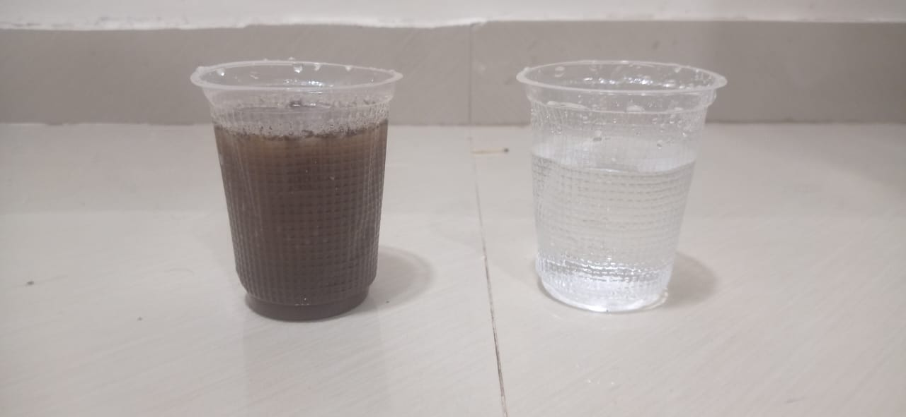
Figure 5.1. Water samples

Our system was tested with different water samples, in which we took a clean water sample and dirty water sample.
The collected sensor readings are shown in below table:
Water Sample | Turbidity (%) | TDS (ppm) | Temperature (°C)
1.Clean water | 10% | 31.40 ppm | 29.31°C
2.Dirty water | 70% | 118.07 ppm | 30.00°C

- Clean water showed the lowest Turbidity & TDS, making it the cleanest.
- Dirty water has the high Turbidity and TDS level, indicating contaminated.
- Temperature varied slightly based on the environment conditions.

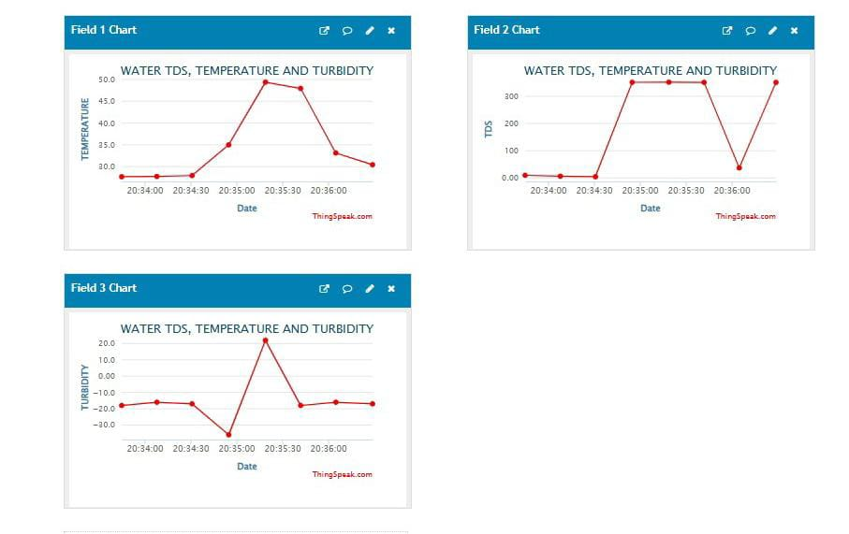

Figure 5.2. Thingspeak data
Thingspeak is displaying the data (Turbidity, TDS, & Temperature) of water over time. Each field represents different sensor data:
1)Field 1(Temperature): - It shows the variations in temperature of water.
2)Field 2(TDS- Total dissolved solids): - It indicate the quality of water based on the dissolved solids in water.
3)Field 3(Turbidity): - It represents the clarity of water.
5.2. How IoT- Based water Testing is Better?
Traditional Method | IoT Based system
Collecting the data was slow | Collecting data is fast
Remote monitoring is not possible | Remote monitoring is possible
It required labs & trained person | Data is automatically collected
Time consuming and costly | Real-time monitoring and affordable

5.3. The system: -
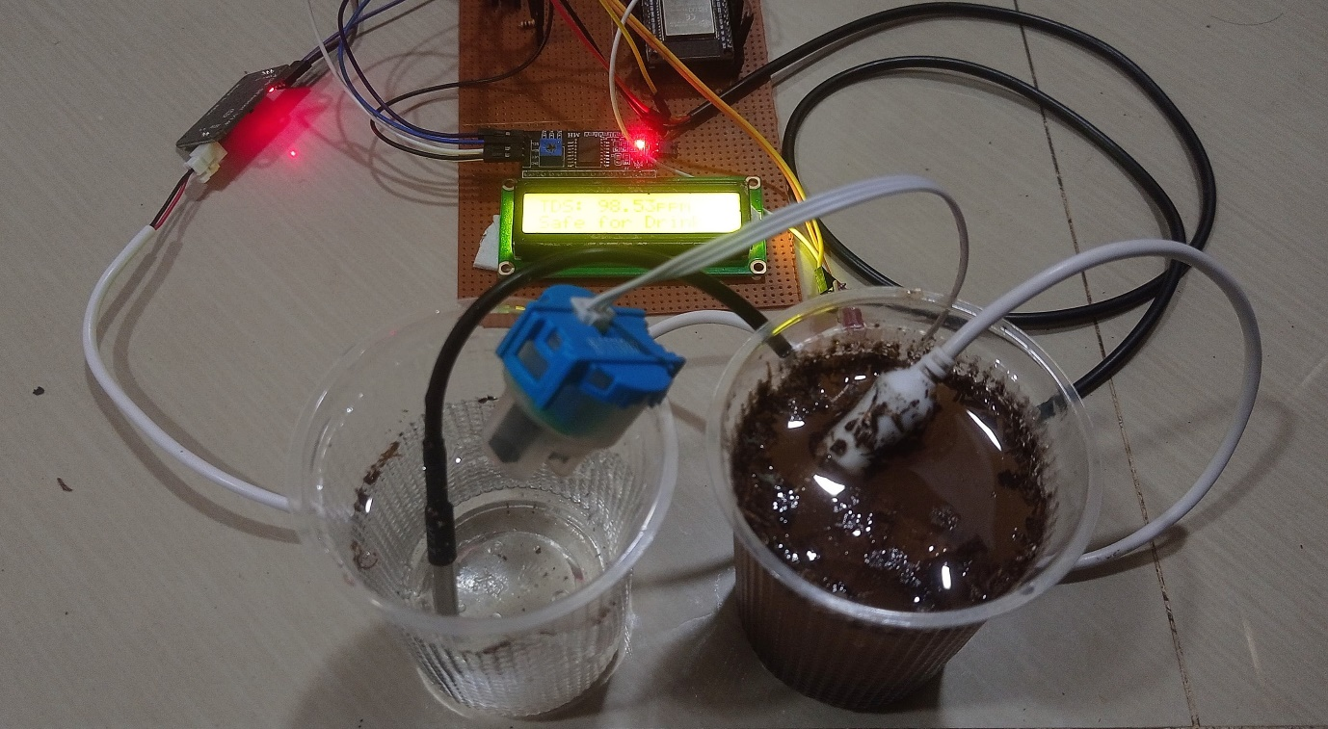
Figure 5.3. IoT-Based water quality monitoring system
This is our system an “IoT-Based water quality monitoring system" using Turbidity, TDS, & Temperature sensor interfaced with ESP32. The LCD screen display sensor value and water quality status. The ESP32 is connected with a mobile hotspot which continuously sends the data to thingspeak cloud with the delay of one second.
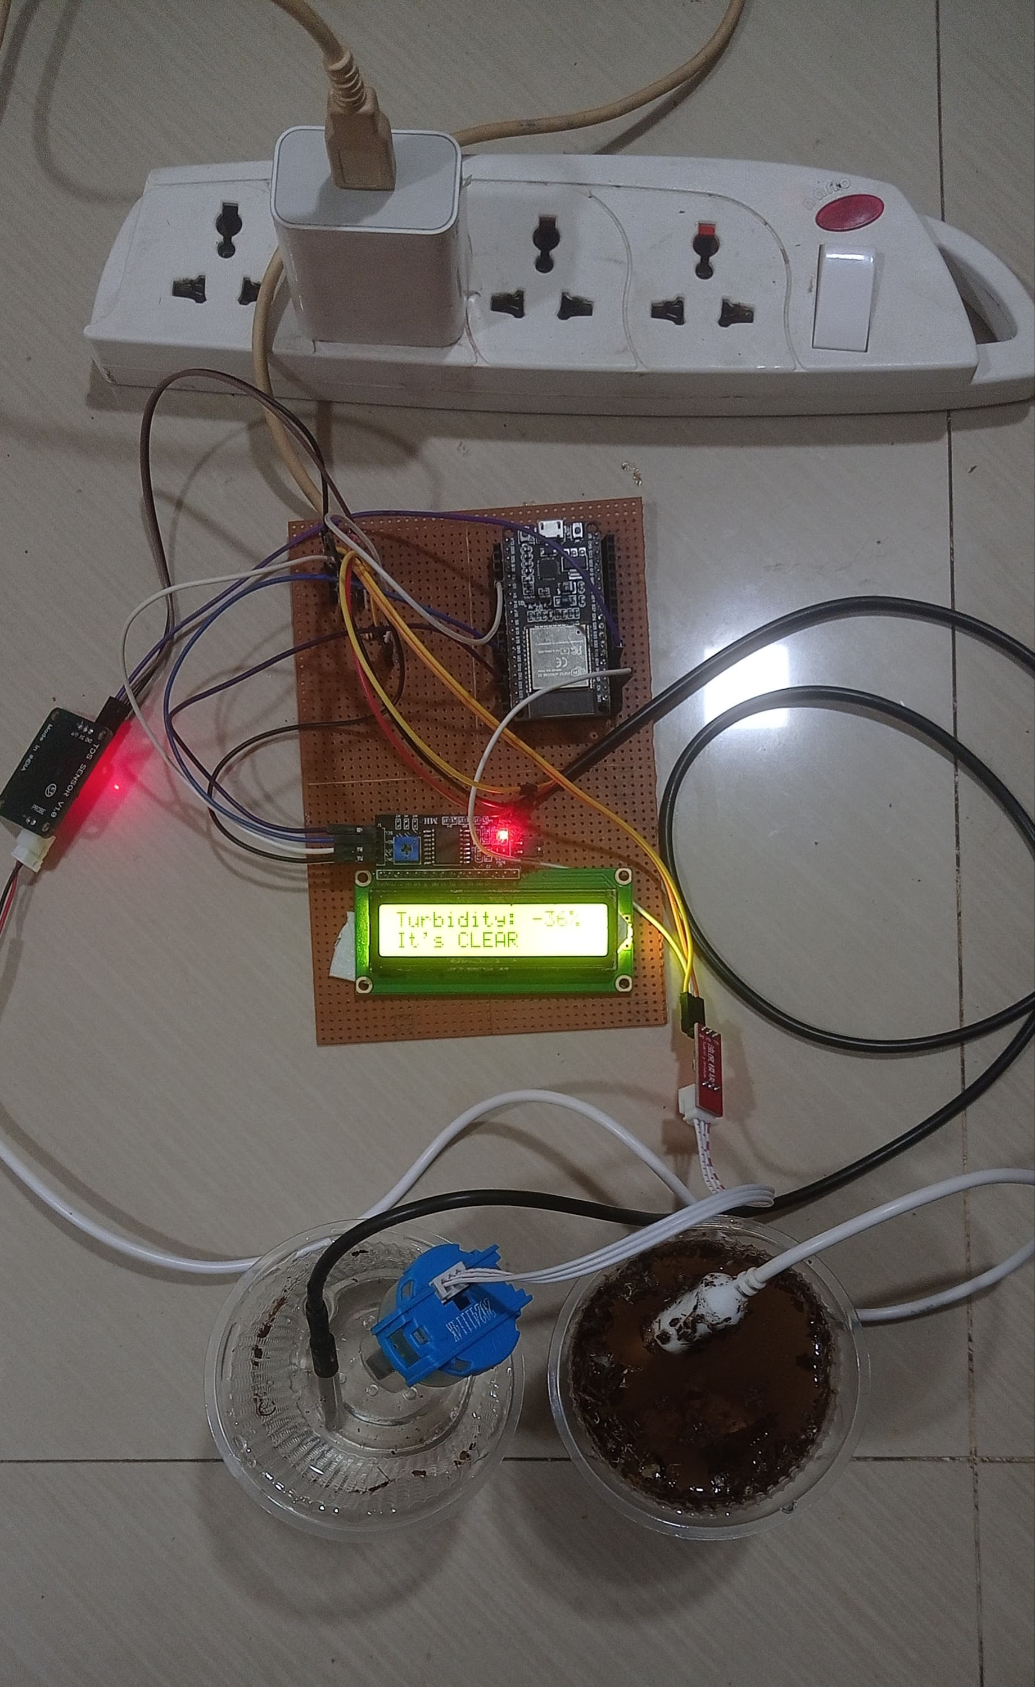

5.4 Observation from our setup: -
1)Temperature sensor (DS18B20): - It is immersed in both samples, to measure the temperature of water.
2)Turbidity sensor: - It is insert in both samples to measure the turbidity level of the clean and dirty water.
3)TDS sensor: - It is used to measure the dissolved solids in both samples.
4)LCD display: - Show real time sensor value.
5)ESP32: - Collect the sensor data & send to thingspeak for remote monitoring.

6. Conclusion and Future work:
Water quality is a very important factor in our daily life. Monitoring parameter of water (turbidity, TDS, Temperature) unsure the good quality of water for our drinking and daily use.
This system can automatically monitor the water quality with the help of different sensors
And this system is cost effective with good accuracy, this eliminates the need for people to test and monitor water quality in laboratory. This makes water quality testing more conventional and faster and display the result on the LCD display. This system is very simple and easy to use, sensors can be easily interfaced, and software changes can be done for more advanced system integration. With the help of this system remote monitoring is possible which is a major advantage of this system. This system is suitable for various applications like household, industrial and agriculture water monitoring.
Future work:
1) Mobile app development: - A mobile app can be developed to display the real time water quality, send alerts and notifications.
2) Advance sensor technology: - We will use more advance sensors to monitor the different water parameters in large water bodies like oceans and rivers.
3)Automatic water filtration: -To develop a system that can filter the water automatically based on the detected contamination level.
4) Integrating more sensors: - Adding more sensors to detect more parameters of water.
5) Enabling AI based prediction: - Implementing the AI technology in this system, can be helpful for predicting the future water quality, and adjust water monitoring based on the environment conditions.

REFERENCES:
1) A.N. Prasad, K. A. Mamun, F. R. Islam, H. Haqva (2015). Smart Water Quality Monitoring System. Paper presented at the 2nd IEEE Asia Pacific World Congress on Computer Science and Engineering, Fiji Islands. https://doi.org/10.1109/APWCCSE.2015.7476234
2) Mrs. R.J. Sapkal, Ms. Pooja Wattamwar, Ms. Rani Waghmode, Ms. Umrunsisa Tamboli (2019). A Review - Water Quality Monitoring System. International Journal of Scientific Research in Science and Technology. https://doi.org/10.32628/IJSRST19626.
3) Adetunji A.C, Prof. Mrs F.M Dahunsi (2025). Development Of IoT Water Quality Monitoring System. DOI:10.13140/RG.2.2.29535.16807.
4) Nikhil Kedia, Water Quality Monitoring for Rural Areas- A Sensor cloud based economical project (2015). 1st International Conference on Next Generation Computing Technologies (NGCT). DOI: 10.1109/NGCT.2015.7375081.
5) Taufiqur Rahaman (2025). Smart Environmental monitoring systems for air and water quality management. DOI:10.63125/a08zay47
6)Mehmet Akif Ozturk, Emre Unsal, Ahmet First Yelkuvan (2025). Development of an Internet of Things-Based Ultra-Pure Water Quality Monitoring System. DOI:10.3390/s25041186.
7) Thingspeak, Cloud IoT analytics platform for sensor data. [Online]. Available: https://thingspeak.com/
8)DFRobot, Turbidity sensor with module [Datasheet]. https://www.dfrobot.com
9)Alldatasheet.com, DS18B20 Waterproof Temperature Sensor Cable [Datasheet].
https://www.alldatasheet.com
10)DFRobot, Analog TDS Sensor [Datasheet]. https://www.dfrobot.com
11) How To Electronics. (2022, Jul 22). IoT Based Drinking Water Quality Monitoring System with ESP32 [video]. https://youtu.be/zi1b_tuzqNM?si=Yeb9KOOkBj0lz0Ur

